Test Case: tc001_SPX_Dev5_Crear_Solicitud_Articulo_Almacen
Step 1 - Enter username and password and click to button Enter : Credentials Entered
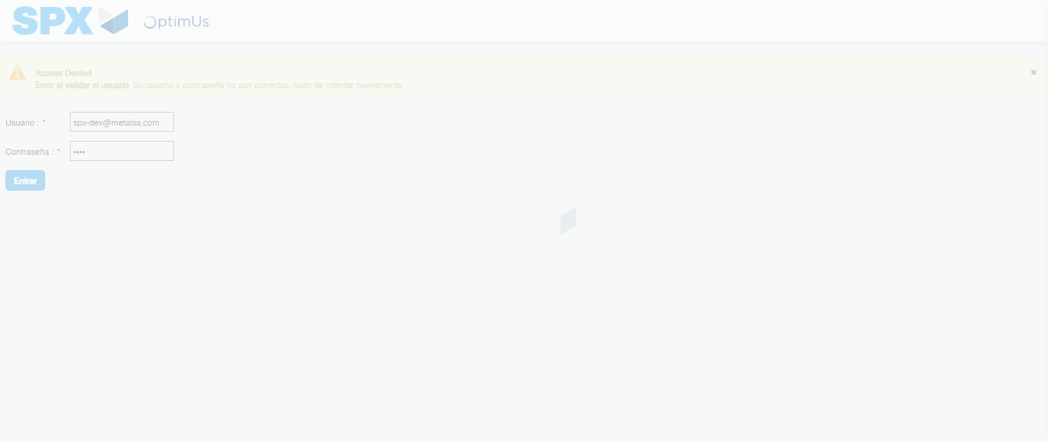Image file-name: QC_Testing-tc001_SPX_Dev5_Crear_Solicitud_Articulo_Almacen-1787939238218

Step 2 - Select to UEN and Access to Request for a New Inventory Item : UEN Correctly selected and Correct access
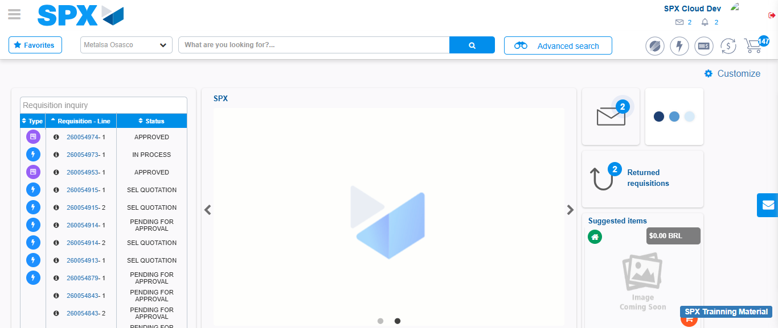Image file-name: QC_Testing-tc001_SPX_Dev5_Crear_Solicitud_Articulo_Almacen-1787939280395

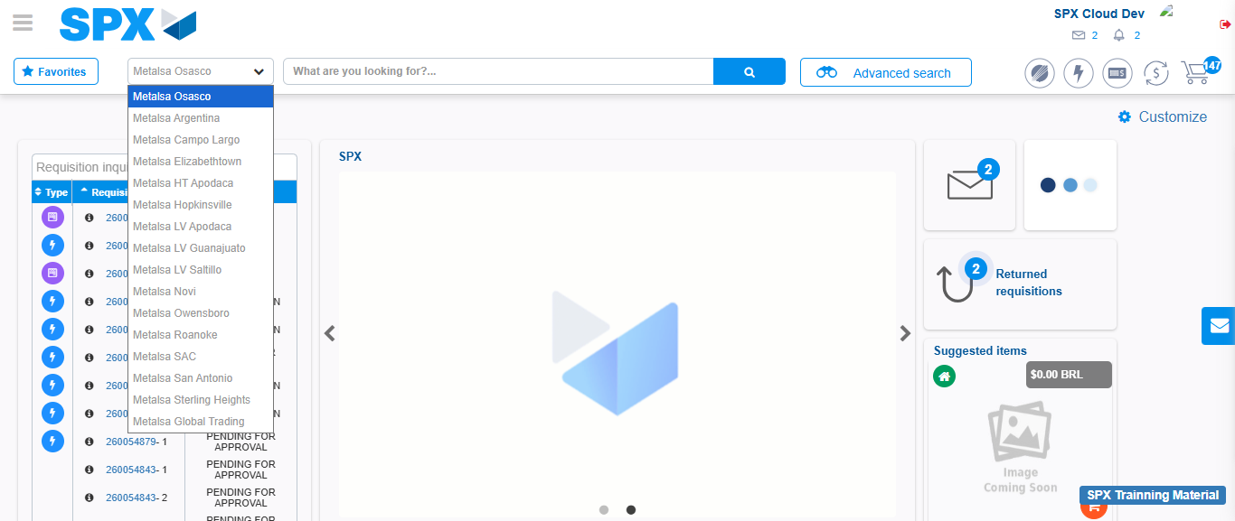Image file-name: QC_Testing-tc001_SPX_Dev5_Crear_Solicitud_Articulo_Almacen-1787939281142

Image file-name: QC_Testing-tc001_SPX_Dev5_Crear_Solicitud_Articulo_Almacen-1787939291196

Step 3 - Select options first section : Options seleted correctly
Image file-name: QC_Testing-tc001_SPX_Dev5_Crear_Solicitud_Articulo_Almacen-1787939291427

Image file-name: QC_Testing-tc001_SPX_Dev5_Crear_Solicitud_Articulo_Almacen-1787939291594

Step 4 - Select options at Screen: Options seleted correctly
Image file-name: QC_Testing-tc001_SPX_Dev5_Crear_Solicitud_Articulo_Almacen-1787939291427

Image file-name: QC_Testing-tc001_SPX_Dev5_Crear_Solicitud_Articulo_Almacen-1787939291594

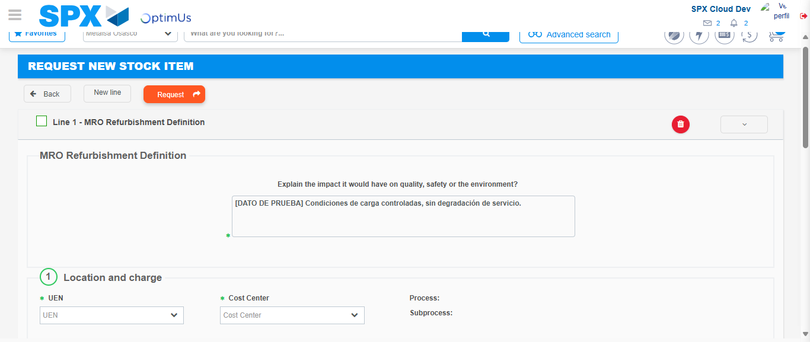Image file-name: QC_Testing-tc001_SPX_Dev5_Crear_Solicitud_Articulo_Almacen-1787939303532

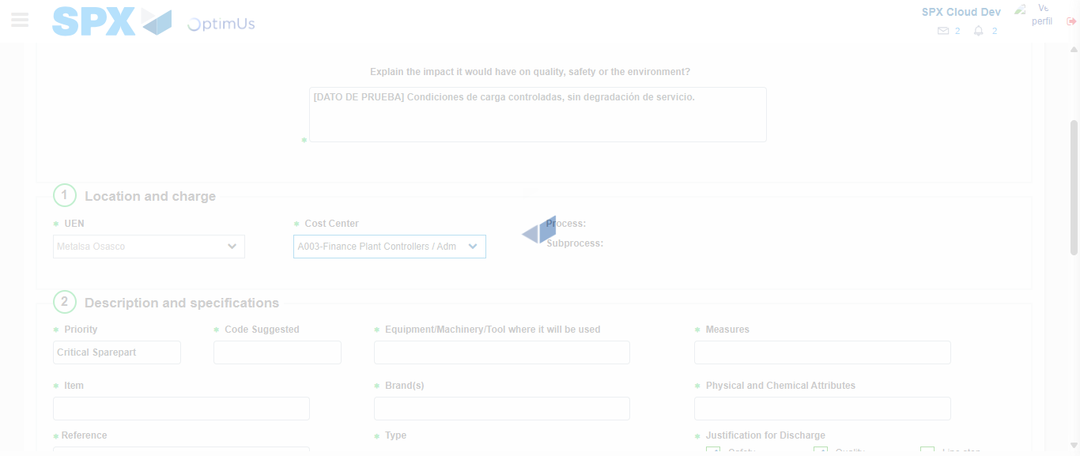Image file-name: QC_Testing-tc001_SPX_Dev5_Crear_Solicitud_Articulo_Almacen-1787939305865

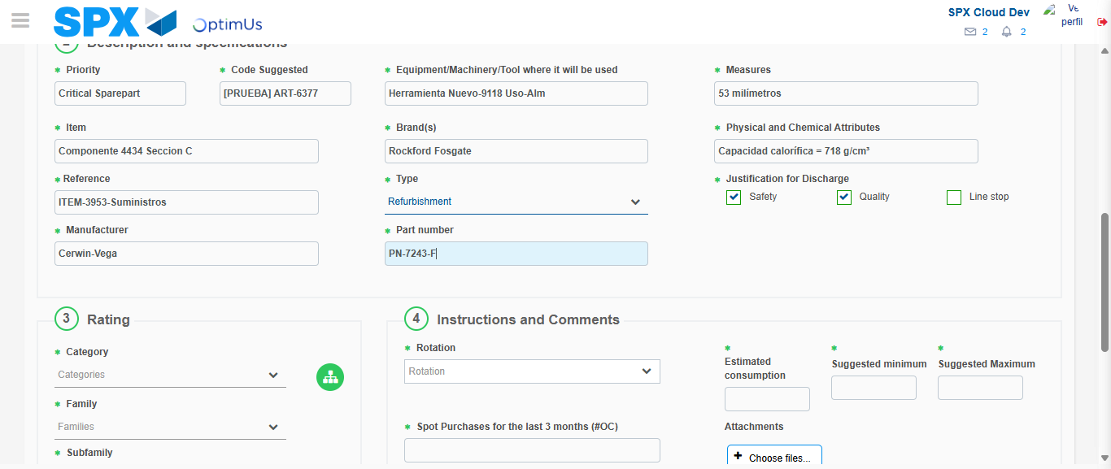Image file-name: QC_Testing-tc001_SPX_Dev5_Crear_Solicitud_Articulo_Almacen-1787939307012

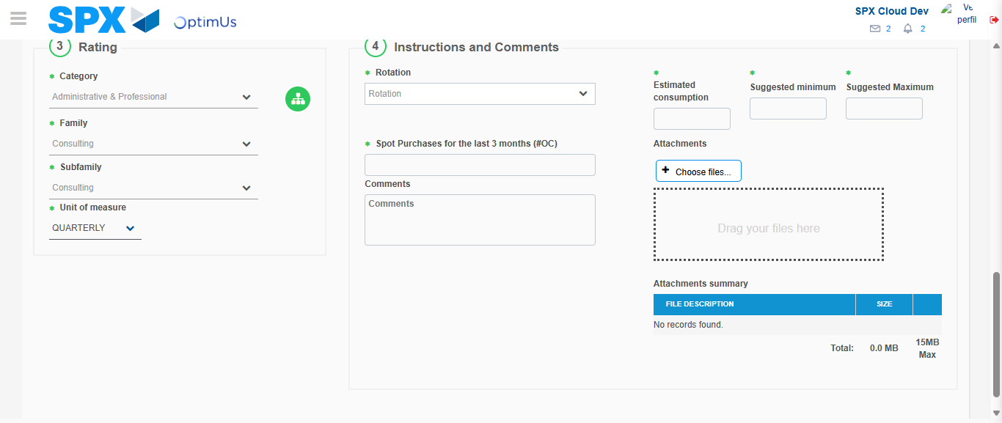Image file-name: QC_Testing-tc001_SPX_Dev5_Crear_Solicitud_Articulo_Almacen-1787939310943

Step 5 - Request New Item : Request Accepted
Image file-name: QC_Testing-tc001_SPX_Dev5_Crear_Solicitud_Articulo_Almacen-1787939280395

Image file-name: QC_Testing-tc001_SPX_Dev5_Crear_Solicitud_Articulo_Almacen-1787939281142

Image file-name: QC_Testing-tc001_SPX_Dev5_Crear_Solicitud_Articulo_Almacen-1787939291196

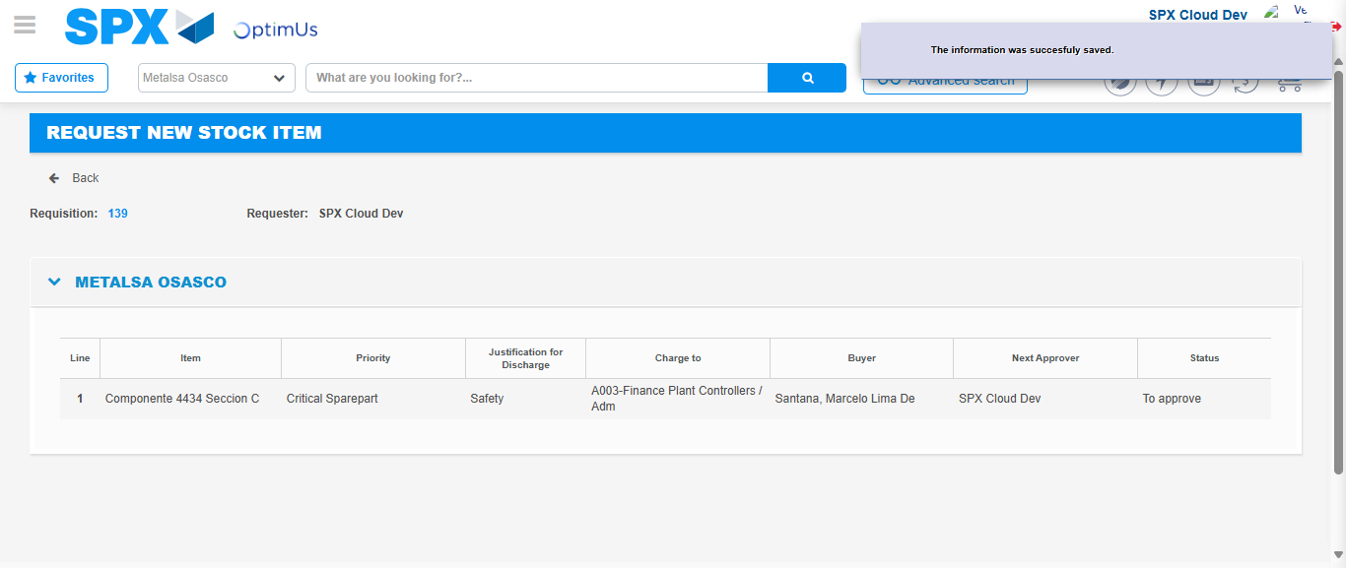Image file-name: QC_Testing-tc001_SPX_Dev5_Crear_Solicitud_Articulo_Almacen-1787939318367

Image file-name: QC_Testing-tc001_SPX_Dev5_Crear_Solicitud_Articulo_Almacen-1787939318517

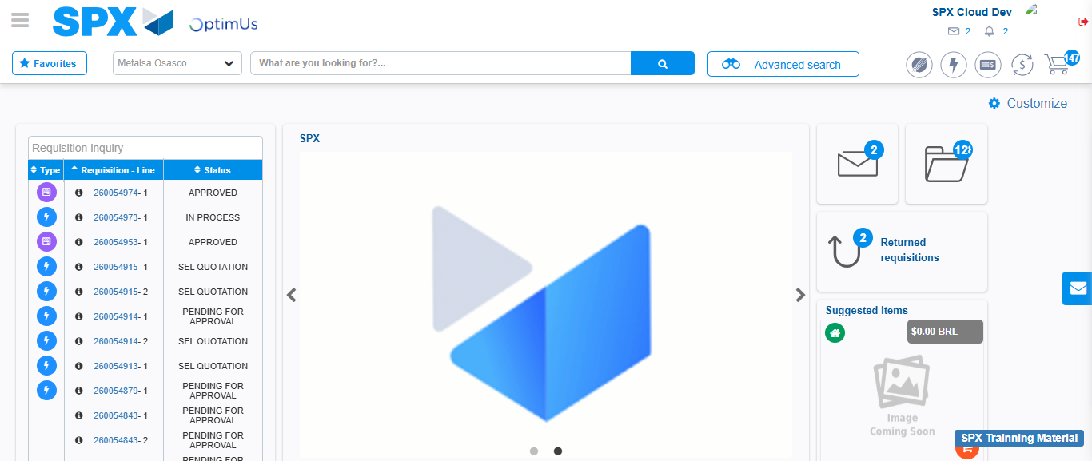Image file-name: QC_Testing-tc001_SPX_Dev5_Crear_Solicitud_Articulo_Almacen-1787939339761

Step 7 - Return to Main Page SPX : Return to Main Page SPX
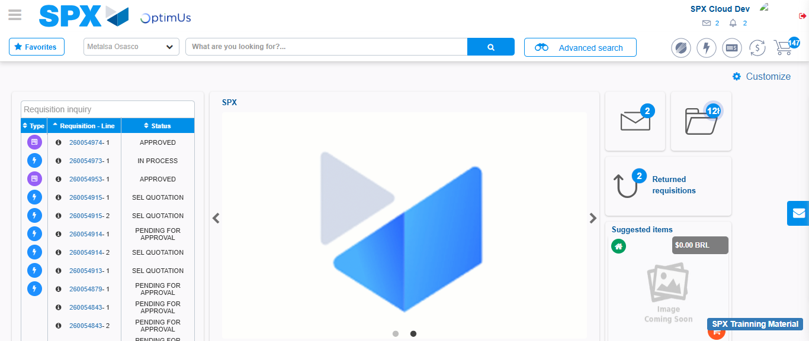Image file-name: QC_Testing-tc001_SPX_Dev5_Crear_Solicitud_Articulo_Almacen-1787939340104

